Schedule

National Student Wellbeing Program
FEDERATIOn FUNDING AGREEMENT – EDUCATION AND SKILLS

Table 1: Formalities and operation of Schedule
Parties | Commonwealth  New South Wales  Victoria  Queensland  Western Australia  South Australia  Tasmania  Australian Capital Territory  Northern Territory
Duration | This Schedule is expected to expire on the later of 30 June 2028, or completion of deliverables, including final performance reporting and processing of final payments against milestones.
Purpose | This Schedule is made for the purposes of the Federation Funding Agreement-Education and Skills (FFA).  This Schedule will support the wellbeing of Australian school students through the delivery of the National Student Wellbeing Program (NSWP) in the 2023, 2024, 2025, 2026 and 2027 school years.  The NSWP consists of the provision of chaplaincy and/or student wellbeing services in Australian schools to support the wellbeing of Australian school students through:  - pastoral care services; and  - strategies developed in consultation with the school community, relevant school staff and school principal, that support the wellbeing of the broader school community, for example: coordinating volunteering activities and support, breakfast clubs, lunch time activities, excursions, school incursions, and parent/carer workshops.  The NSWP is a complementary service to those provided by qualified  specialists. The NSWP is not designed nor intended to provide specialist  services to school students, such as professional counselling,  professional mental health and psychological services and other allied  health services. In addition, the NSWP is not a religious program and  does not provide religious instruction or religious counselling to  students.
Estimated financial contributions | The Commonwealth will provide an estimated total financial contribution to the States of $307.18 million in respect of this Schedule All payments are GST exclusive.  The Commonwealth’s contribution to each State for NSWP school funding is up to the maximum amount in Table 1A.  The States may use up to 3% of their funding for administration of the NSWP.  Table 1A ($ million) 2022-23 2023-24 2024-25 2025-26 2026-27 Total  Total National Partnership payments 61.43 61.43 61.43 61.43 61.43 307.18  New South Wales 11.27 11.27 11.27 11.27 11.27 56.34  Victoria 12.79 12.79 12.79 12.79 12.79 63.95  Queensland 18.35 18.35 18.35 18.35 18.35 91.75  Western Australia 7.73 7.73 7.73 7.73 7.73 38.64  South Australia 7.59 7.59 7.59 7.59 7.59 37.97  Tasmania 2.22 2.22 2.22 2.22 2.22 11.09  the Australian Capital Territory 0.98 0.98 0.98 0.98 0.98 4.88  the Northern Territory 0.51 0.51 0.51 0.51 0.51 2.55  Note: Figures may not add due to rounding
Additional terms | Role of the Commonwealth  - In addition to Clause 19 of the FFA (Role of the Commonwealth), the Commonwealth will be responsible for:  - providing reporting templates to the States to support the requirements of Table 1A and Item 4 (Reporting Arrangements) in this Schedule;  - allowing States to use up to three per cent (3%) of total NSWP school funding for the administration of the NSWP; and  - facilitating information sharing with the States regarding the delivery of the NSWP.  Role of the States  - In addition to Clause 20 of the FFA (Role of the States and Territories), States will be responsible for:  - inviting all schools in all sectors in their jurisdiction to apply to participate in the NSWP  - establishing a Cross Sector Panel (consisting of government, Catholic and independent school representatives) to select and prioritise schools for funding, having regard to the assessment criteria and selection methodology developed by the Panel that at minimum considers school need, distribution between sectors and other school wellbeing support arrangements in the jurisdiction;  - continuing the operation of each Cross Sector Panel to select alternative schools, should some schools withdraw from the NSWP before the expiry of this Schedule;  - putting in place appropriate processes to ensure that:  - participation by schools and students is voluntary;  - chaplains and student wellbeing officers may be of any faith or of no faith;  - chaplains and student wellbeing officers must:  - not proselytise;  - respect, accept and be sensitive to other people's views, values and beliefs;  - promote a safe and inclusive school community, where all people are respected;  - have relevant and valid State and Working With Children or Vulnerable People Checks. Where chaplains and student wellbeing officers are not required to have a valid Working with Children or Vulnerable People Check in a State, that State will be responsible for putting in place appropriate processes to ensure that chaplains and student wellbeing officers a National Police Check; and  - meet the NSWP's minimum qualification and professional development requirements as set out in Items 5c and 5d of this Schedule.  - chaplains and student wellbeing officers are to be aware of and:  - comply with State and Territory laws and policies in relation to child protection and child safety matters;  - comply with, relevant legislation relating to requirements for working with children, and relevant legislation relating to mandatory reporting of suspected child abuse or neglect;  - have regard to the National Principles for Child Safe Organisations (which in 2022, can be viewed on the  Australian Human Rights Commission website at https://childsafe.humanrights.gov.au/national-principles);  - have regard to the national policies and strategies led by the National Office for Child Safety, including the Commonwealth Child Safe Framework (which in 2022, can be viewed on the National Office for Child Safety website at https://childsafety.pmc.gov.au/);  - publishing on their public-facing website their guidelines or other relevant documentation for delivering the NSWP that is consistent with the terms and conditions of this Schedule and that outlines:  - how schools apply for NSWP funding;  - the Cross Sector Panel arrangements;  - the assessment criteria and selection methodology for NSWP funding applications;  - the NSWP provider and/or funding recipient arrangements, including compliance with the Schedule;  - the roles and responsibilities of chaplains and student wellbeing officers, including a code of conduct;  - that participation by students in the NSWP is voluntary and the consent mechanism that supports this;  - the process for complaints handling, including maintaining a complaints register;  - publishing on their public-facing website:  - the list of schools receiving chaplaincy and/or student wellbeing services in their State, including the provider or funding recipient delivering NSWP services to their State’s schools. This list is to be kept current and updated as required; and  - their Terms of Reference for the Cross Sector Panel;  - distributing up to $20,280 to, or on behalf of, each school (or up to $24,336 to, or on behalf of, each school in a remote/very remote area) that has been selected for funding.  Shared roles and responsibilities  - In addition to Clause 21 of the FFA (Shared roles and responsibilities), the Commonwealth and the States agree to be jointly responsible for participating in an independent evaluation of the NSWP, to be arranged by the Commonwealth in consultation with the States. The draft evaluation report will be provided to States for comment prior to finalisation of the report.  Reporting Arrangements  - The States will provide annual milestone reports to the Commonwealth during the operation of this Schedule (2023-2028) in accordance with Table 1A and Table 2 (report due dates) and including but not limited to:  - Provision of the list of schools selected for funding in the following year;  - Final list of schools that had chaplaincy and/or student wellbeing services and the amount of funding provided per school for the previous school year;  - Number, locality (metropolitan, regional, remote, very remote) and sector (government, Catholic and independent) of schools that applied for NSWP chaplaincy and student wellbeing services;  - Confirmation that the requirements set out in Item 2b) and 2c) of this Schedule were met during the school year the reporting relates to;  - Cross Sector Panel Terms of Reference, membership and methodology used for school selection; and  - At least one example of how the NSWP has supported the wellbeing of a school community in that year. This example may be published or used in the evaluation of the NSWP.  Interpretation  - In addition to Clause 47 of the FFA, for the purpose of this Schedule:  - A chaplain is an individual who:  - is recognised by the school community and the appropriate governing authority for the school as having the skills and experience to deliver school chaplaincy services to the school community; and  - is recognised through endorsement by a recognised or accepted religious institution (as determined by the States); and  - meets the NSWP's minimum qualification requirements as specified in Item 5c below.  - A student wellbeing officer is an individual who:  - is recognised by the school community and the appropriate governing authority for the school as having the skills and experience to deliver student wellbeing services to the school community; and  - meets the NSWP's minimum qualification requirements as specified in Item 5c below.  - Chaplains and student wellbeing officers are required to hold a minimum qualification or qualifications equivalent to or higher than a Certificate IV as determined by the States, and this qualification or qualifications must include competencies in:  - mental health and making appropriate referrals, and  - providing pastoral care, and/or working with youth.  - Chaplains and student wellbeing officers are also required to undertake a professional learning package in responding to and preventing cyberbullying delivered by the Office of the eSafety Commissioner within three months of commencing NSWP services and refresh this professional learning at least once every two and a half years.  - Pastoral care is the practice of supporting the general wellbeing of students and the school community.  - Remote/very remote areas are those geographical areas classified as such by the Accessibility/Remoteness Index of Australia Plus, or as determined by the States in line with their school classification processes.

Table 2: Performance requirements, reporting and payment summary
Output | Performance milestones | Report due | Payment
Preparation for the delivery of the NSWP in 2023 | Have in place a Cross Sector Panel by no later than January 2023 consistent with Item 2b in this Schedule.  Provision of reporting in accordance with Item 4 in this Schedule.  Delivery of the NSWP in 2022 consistent with the reporting arrangements in the previous Project Agreement for the National School Chaplaincy Program (2019 to 2022 school  years). | 01/03/2023 | In accordance with Table 1A and Item 1b in this Schedule
Delivery of the NSWP in 2023 to 2027 school years and provision of reporting (2024 to 2028) | Continued operation of the Cross Sector Panel and selection methodology. Consistent with Item 2b in this Schedule.  Delivery of the NSWP consistent with Items 2b) and 2c) in this Schedule.  Provision of reporting in accordance with Item 4 in this Schedule. | 01/03/2024
 |  | 03/03/2025
 |  | 02/03/2026
 |  | 01/03/2027
 |  | 01/03/2028 | Not applicable

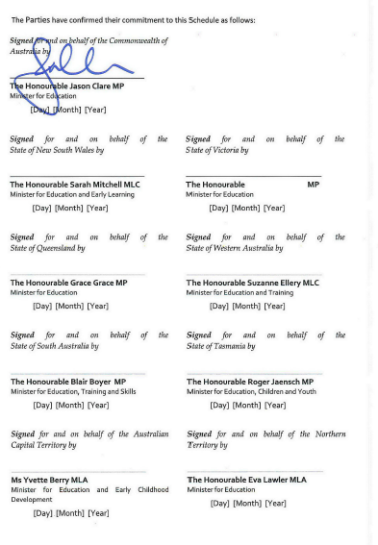

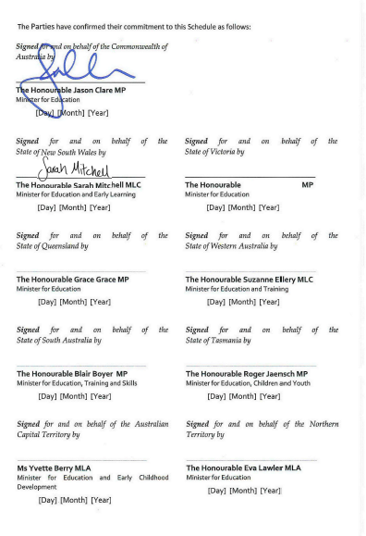

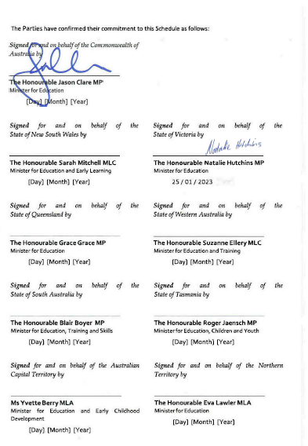

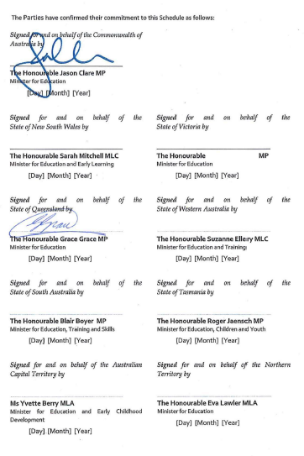
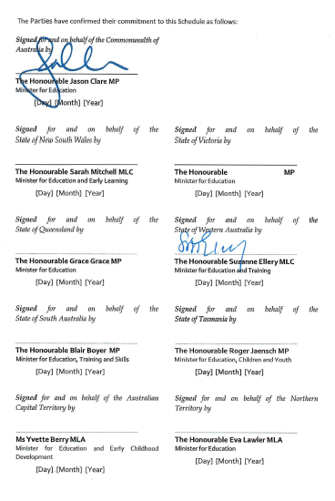

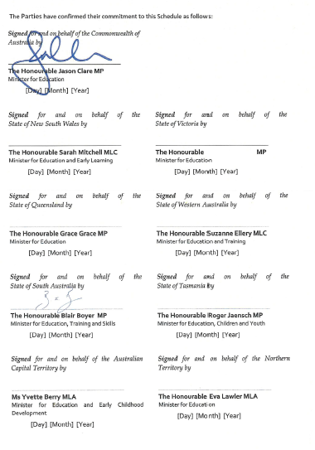

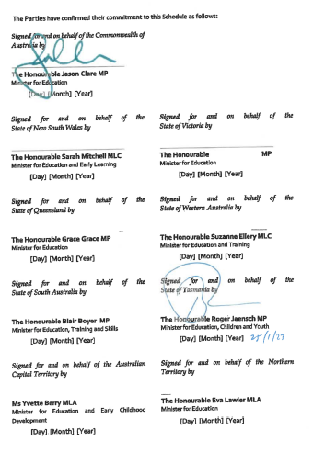

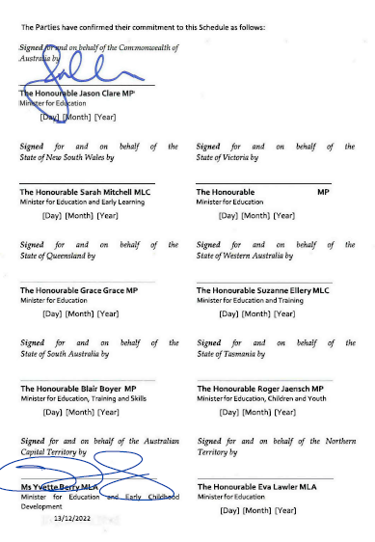
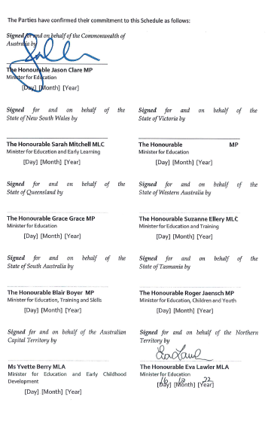

Under the NSWP a title other than 'chaplain' may be used where the title is appropriate to the religious affiliation of the individual.
Under the NSWP a title other than 'student wellbeing officer' may be used where the title is appropriate to the school community.

